1. **Create project:** Click on the create project button it will take you to the project creation page.

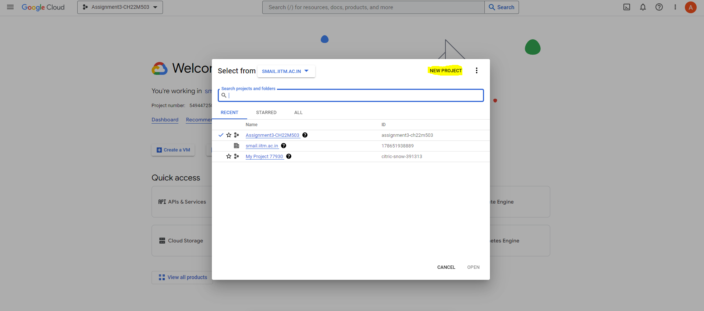

1. Project creation page – Fill out the Project name and click on the create button.

1. If the project gets created successfully then successful notification will appear at the top right corner in the notification section.

1. Choose the project from the top left dropdown and make sure your newly created project appears,

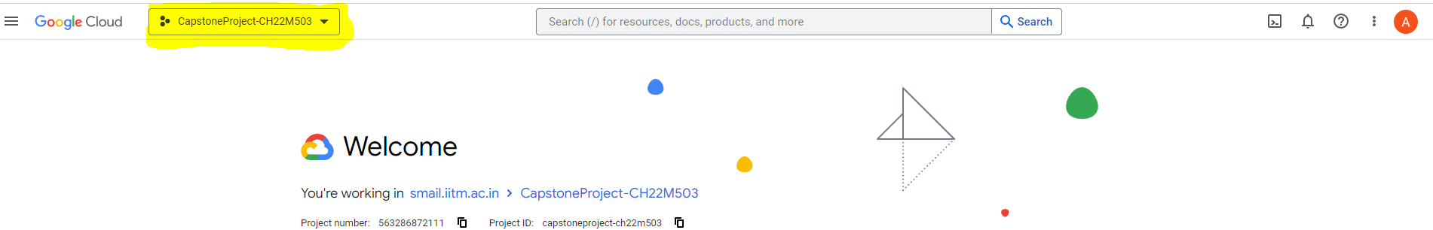

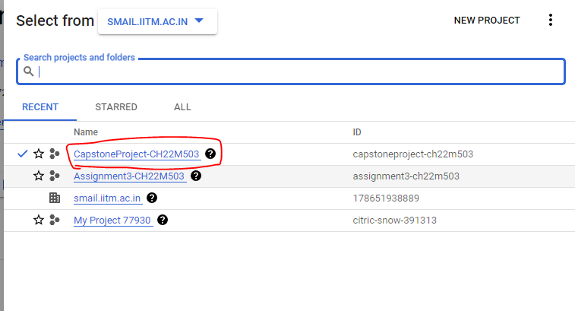

1. **Create a Colab GCP VM –**

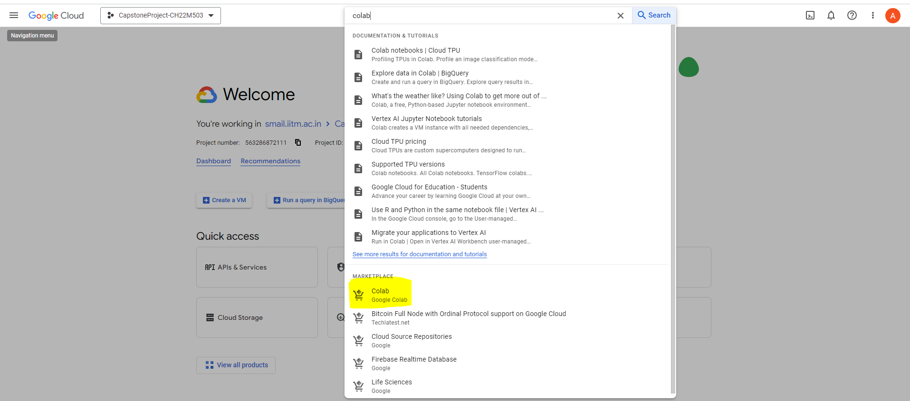

1. You will see a pop-up which gives you a list of APIs that you need to enable. Type them in the search bar to enable them one-by-one. Please note that the redirection from the list itself will not take you to the right place.

Click **‘Launch’**

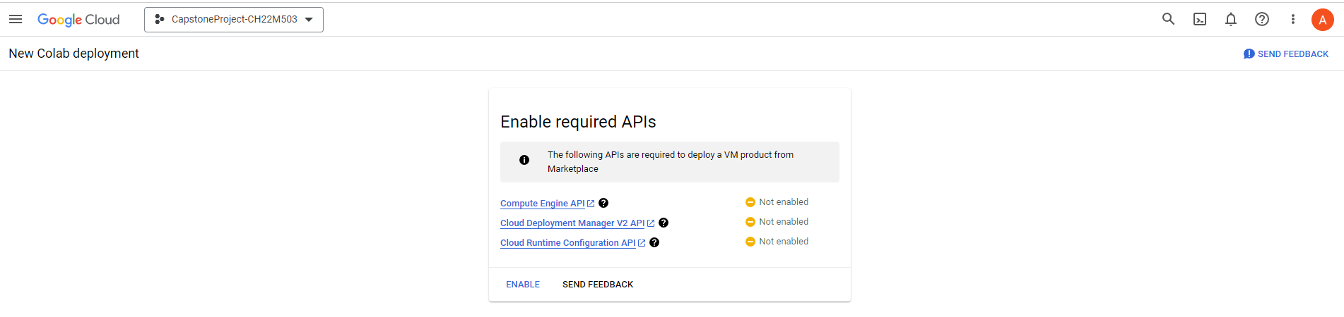

Click **‘Enable’**

Once the required API’s are enabled it will take you through ‘New Colab Deployment’ page.

Create a new Colab accessible VM. Ensure that all the highlighted steps are performed.

For GPU, please delete the entry since GPU is not needed (and too expensive to be afforded in the

free-tier credits provided to us.

Click on ‘Deploy’ button at the bottom of the page.

Wait for your deployment to be ready.

Note down “Instance Zone” and “Instance Name” from the screen in front of you.

Note: Before trying out this problem statement we must divide the consumer and producer code into separate file and load in colab.

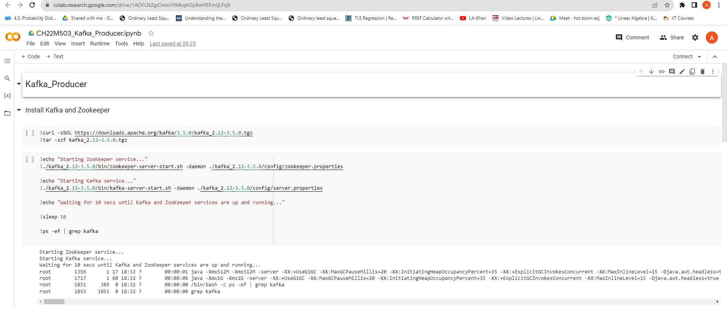

1. Go to your Colab notebook for Producer and follow the steps given to connect the notebook to our newly created VM.
2. Click on connect and then select “Connect to a custom GCE VM”

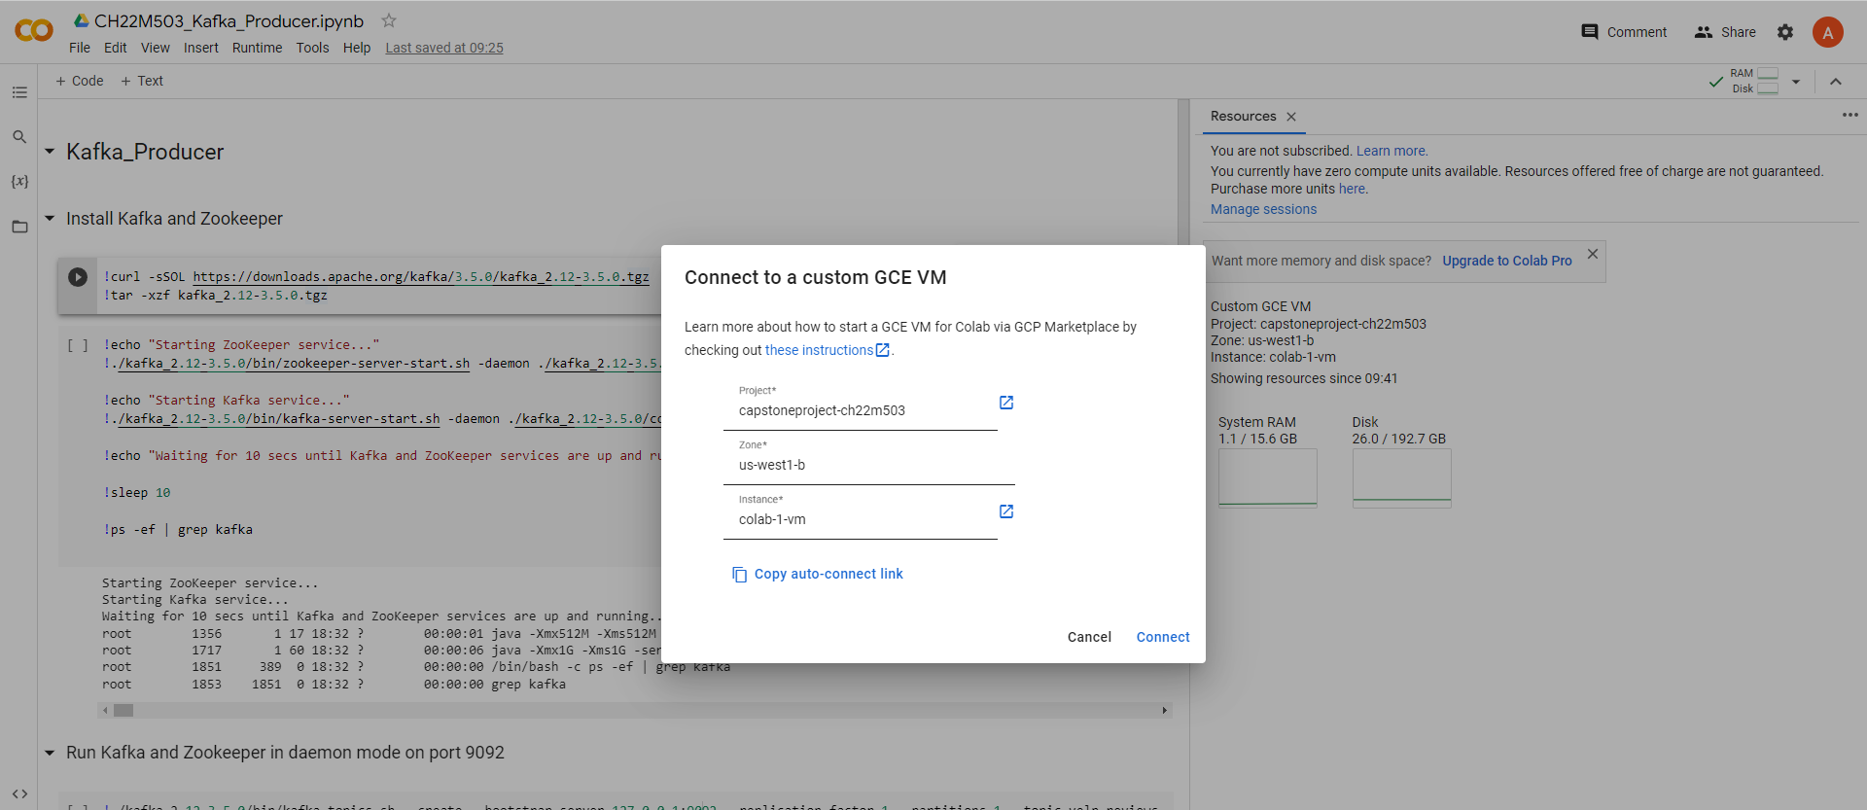

1. Run the Producer and Consumer simultaneously and observe the results.

